 

**WORKSHEET – 1.2**

**Name:** Rahul Maurya

**Section/Group:** 716 / “A”

**UID:** 20BCS7260

**Subject:** Software Engineering Lab

**Date of Submission:** 21.2.2022

**Branch:** BE CSE (4th Semester)

**Aim:**

Consider software for academic activities of a university. The project will cover activities like managing of students as well as faculty. Design a SRS document for the project.

1. **Introduction**

**Purpose:**

This software is for the automation of academic activities of a university. We can store all the data regarding students, faculties and all the information of university including academic, new admission, events and so on.

**CHANDIGARH UNIVERSITY SOFTWARE ENGINEERING LAB**

 

**Document Convention:**

|  |  |
| --- | --- |
| **Abbreviations** | **Full Forms** |
| DB | Database |
| Info | Information |
| ER | Entity Relationships |
| DFD | Data Flow Diagram |
| SRS | Software Requirement Specification |

**Intended Audience:**

This project is for the university management system and it is restricted within the college premises. This has been implemented under the guidance of college professors. This project is useful for the university management as well as for students and faculties.

**Project Scope:**

The proposed software product is University Management System(UIMS). This product will be used in any university, school and educational institute to get information and data from students and faculties and storing the info in the database and using it for further use. The current system is a paper based system, which is too slow and cannot provide updated information about the university.

**References:**

* [**www.google.com**](http://www.google.com)
* [**www.slideshare.net**](http://www.slideshare.net)
* [**www.wikepedia.com**](http://www.wikepedia.com)

**CHANDIGARH UNIVERSITY SOFTWARE ENGINEERING LAB**

 

1. **Overall Description**

**Product Perspective:**

* **USER:** The user can make all the student entries and the total registrations, and the pay the fees.
* **ADMIN:** The admin can see all the information about the students, faculties, university and the admin can add the details too.
* **MANAGEMENT:** The management can add all the information regarding university like fees, events, academics, register something on the system like new admission registration, update the information of students etc.

**CHANDIGARH UNIVERSITY SOFTWARE ENGINEERING LAB**

 

**Product Features:**

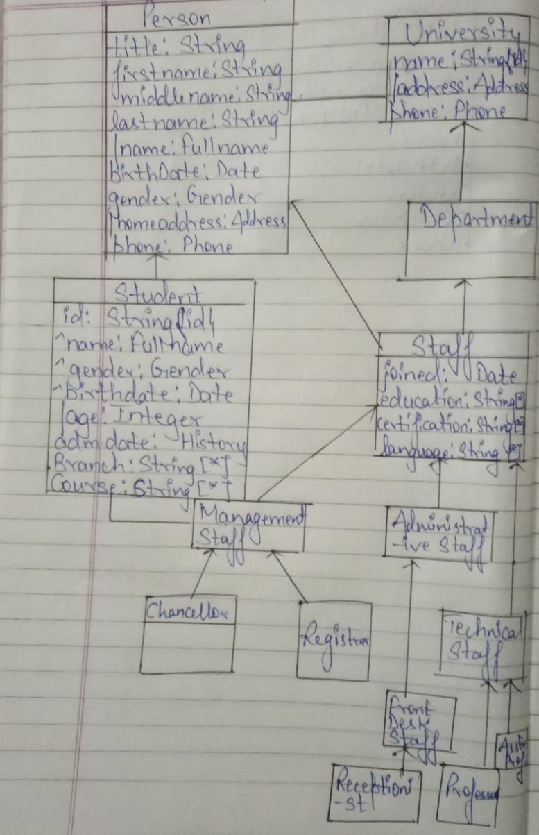

**CHANDIGARH UNIVERSITY SOFTWARE ENGINEERING LAB**

 

**Operating Environment**

Operating environment for the university management system is as listed below:

* Database
* Client / Server system
* Operating System: Windows
* Database: SQL Database(XAMMP)
* Platform: HTML / Java

**Design and Implementation Constraints:**

* SQL commands for above queries / applications.
* Implement the database at least using a centralize database management system.

**Assumption Dependencies:**

Let us assume that this is a distributed university management system and it is used in the following application:

* A request for the application and teachers information.
* Calculation of students and calculating appropriate scholarships for the students.

**CHANDIGARH UNIVERSITY SOFTWARE ENGINEERING LAB**

 

1. **System Features:**

**Description and Priority**

The university management system maintains information on students, faculties and management and about the university. Of course, this project has a high priority because it is very difficult to visit any university without prior information.

**Stimulate / Response Sequences**

* To do registration in university.
* Display a detailed list of courses, available seats.
* Confirmation of admission, fees payment.

**Functional Requirements**

* **Distributed Database:**

Distributed database implies that a single application should be able to operate transparently on data that is spread across a variety of different databases and connected by a communication network.

* **Client / Server System:**

The term client/server refers primarily to an architecture or logical division of responsibilities, the client is the application (also known as the front-end), and the server is the DBMS (also known as the back-end).

**CHANDIGARH UNIVERSITY SOFTWARE ENGINEERING LAB**

 

A client/server system is a distributed system in which,

* Some sites are client sites and others are server sites.
* All the data resides at the server sites.
* All applications execute at the client sites.

1. **External Interfaces Requirement**

**User Interface**

* Front-end software: HTML and JSP
* Back-end software: Xampp Database.

**Hardware Interface**

* Windows.
* A browser which supports CGI, HTML & JavaScript.

**Software Interface**

Following are the software used for the university management system

|  |  |
| --- | --- |
| **Software Used** | **Description** |
| **Operating System** | We have chosen Windows operating system for its best support and user-friendliness. |
| **Database** | To save the student records, faculties, other records we have chosen MySQL database |

**CHANDIGARH UNIVERSITY SOFTWARE ENGINEERING LAB**

 

|  |  |
| --- | --- |
| **HTML** | To implement the project we have chosen HTML language for its more interactive support. |

**Communication Software**

This project supports all types of web browsers. We are using simple electronic forms for the registration, fees payment and for contact with faculties and management.

1. **Non Functionality Requirement:**

**Safety Requirements**

If there is extensive damage to a wide portion of the database due to catastrophic failure, such as a disk crash, the recovery method restores a past copy of the database that was backed up to archival storage (typically tape) and reconstructs a more current state by reapplying or redoing the operations of committed transactions from the backed up log, up to the time of failure.

**Security Requirement**

Security systems need database storage just like many other applications. However, the special requirements of the security market mean that vendors must choose their database partner carefully.

**Soft Quality Attributes**

* **Availability:** The university should be available on the specified time as many students are waiting for their turn in the queues.

**CHANDIGARH UNIVERSITY SOFTWARE ENGINEERING LAB**

 

* **Correctness:** The student should be treated at correct time and should be treated well according to their needs.
* **Maintainability:** The Admin and User in chargers should maintain correct data of students, faculty, university etc.
* **Usability:** The university schedules should satisfy a maximum number of student needs.

**CHANDIGARH UNIVERSITY SOFTWARE ENGINEERING LAB**